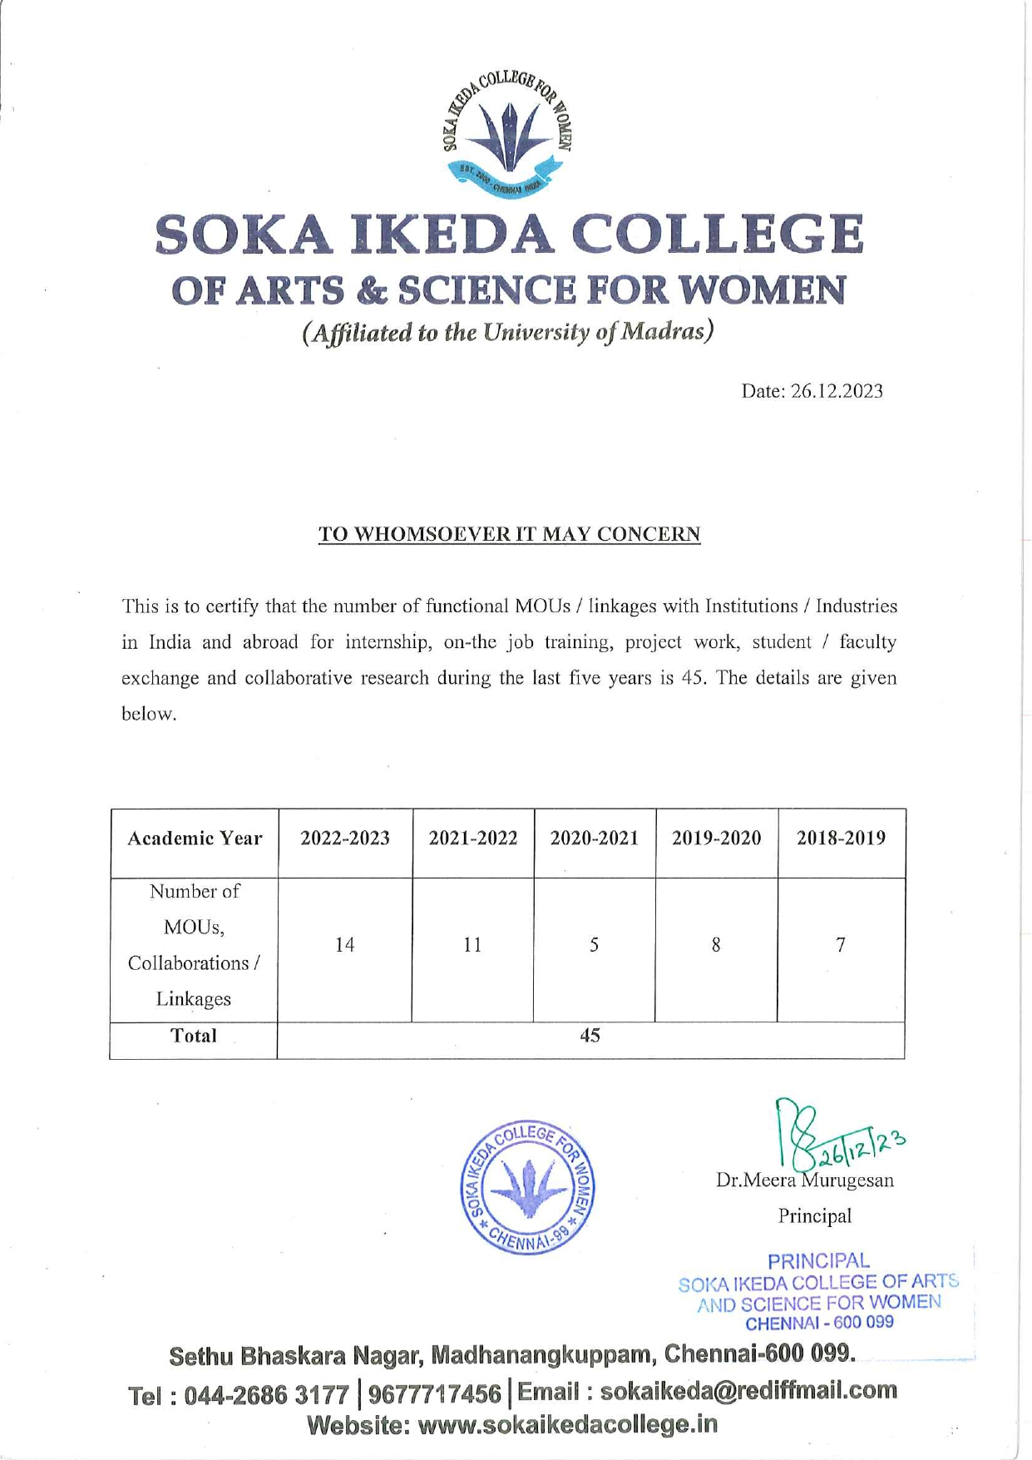



3.5.1. Number of functional MoUs/linkages with institutions/ industries in India and abroad for internship, on-the-job training, project work, student / faculty exchange and collaborative research during the last five years.

S. No. | Description | Link
1 | Summary of the functional MoUs | View
2 | E-Copies of the MOUs / Collaborations / Linkages and activities for the year: 2022-2023 | View
3 | E-Copies of the MOUs / Collaborations / Linkages and activities for the year: 2021-2022 | View
4 | E-Copies of the MOUs / Collaborations / Linkages and activities for the year: 2020-2021 | View
5 | E-Copies of the MOUs / Collaborations / Linkages and activities for the year: 2019-2020 | View
6 | E-Copies of the MOUs / Collaborations / Linkages and activities for the year: 2018-2019 | View

