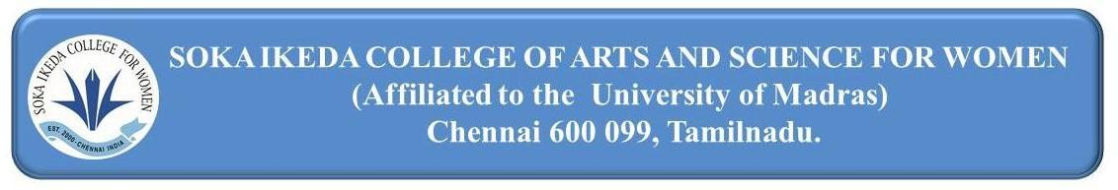
1.2.1. Number of Certificate/Value added courses offered and online courses of MOOCs, SWAYAM, NPTEL etc. where the students of the institution have enrolled and successfully completed during the last five years)
S. NO. | DEPARTMENT | LINK
1 | Tamil | View
2 | English | View
3 | Biochemistry | View
4 | Mathematics | View
5 | Commerce – General | View
6 | Information System Management | View
7 | Economics | View
8 | Corporate Secretaryship | View
9 | Computer Science II | View
EVIDENCE OF COURSE COMPLETION – CERTIFICATES – 2018 – 2019

